**CSS (Text, Font, Opacity, Overflow)**

**Duration 4h (Totally 9)**

**Basic**

**1.Text decoration:**

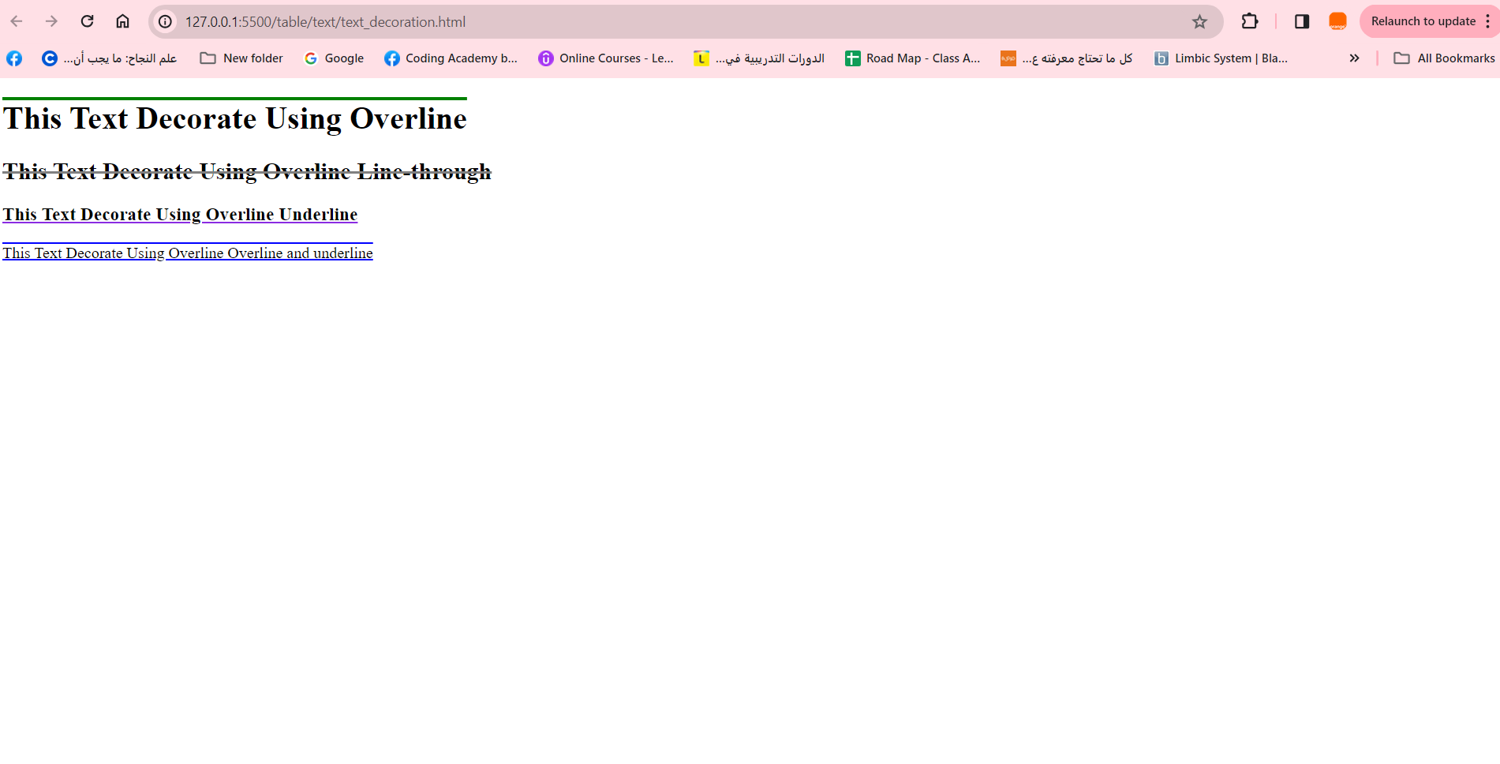

**2.Text transformation:**

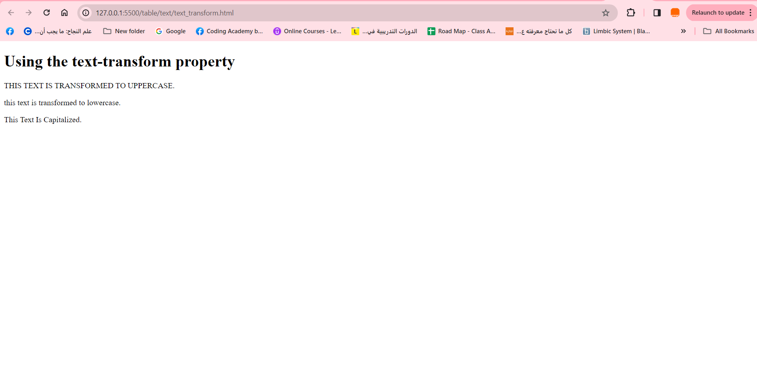

**3.Text align:**

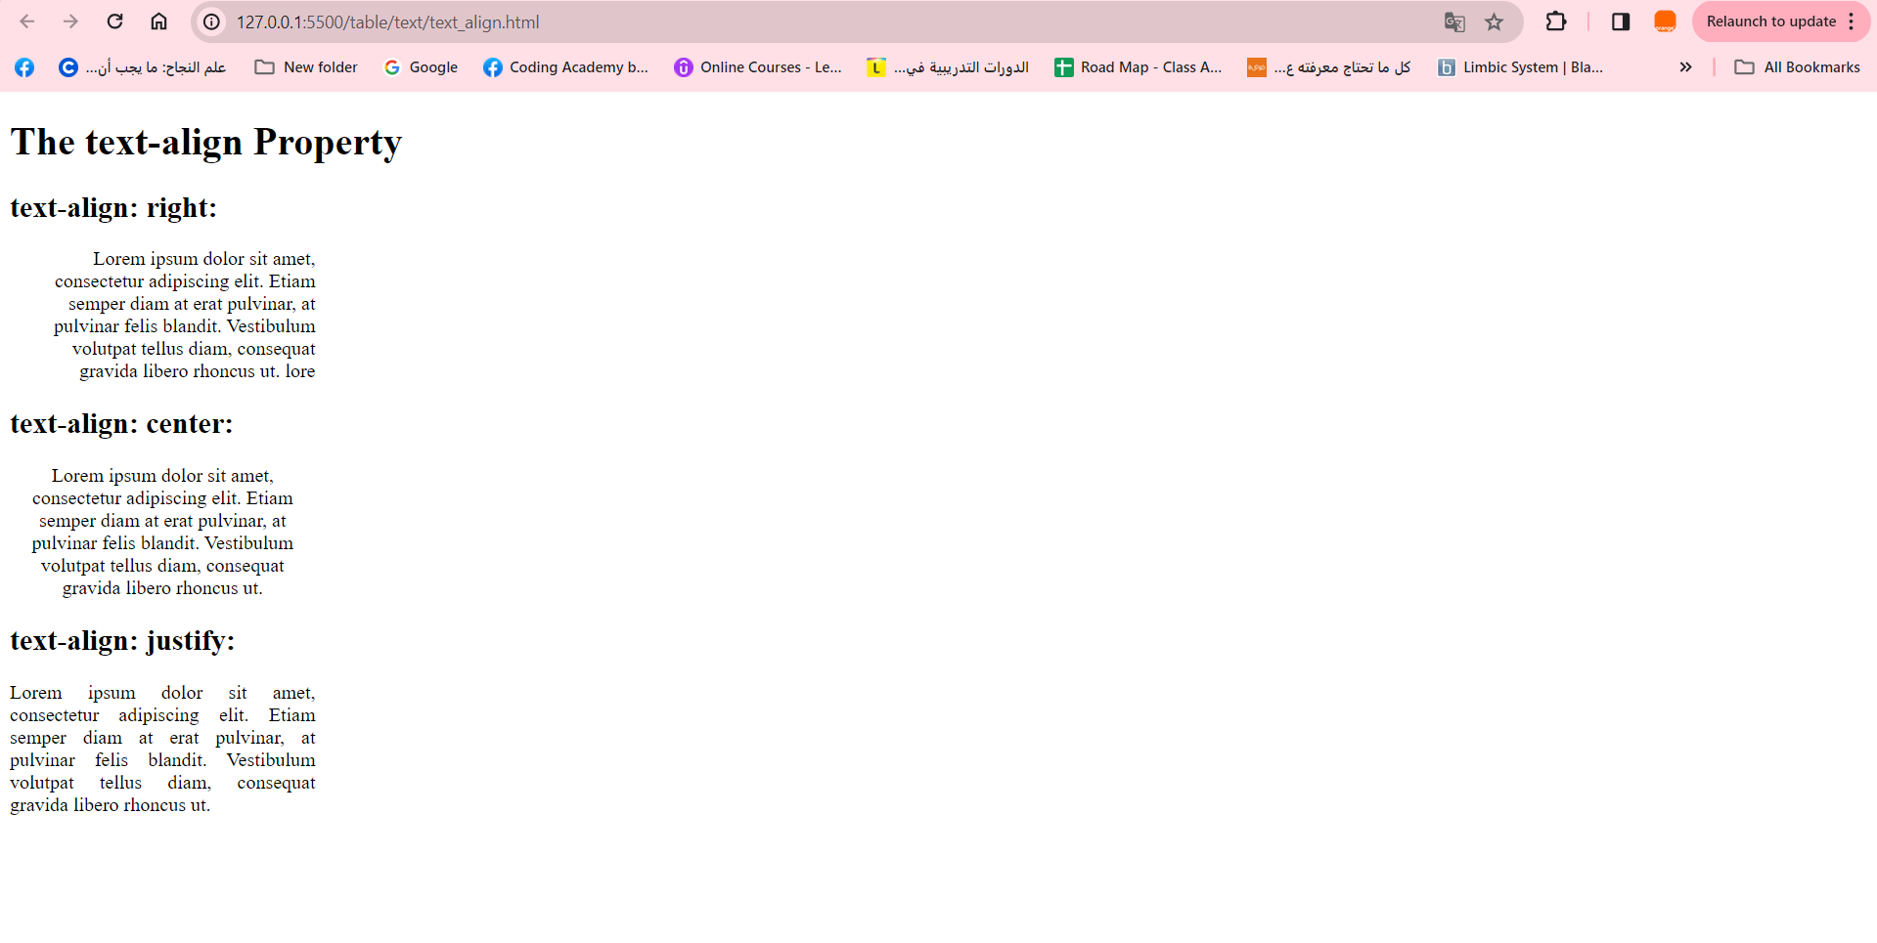

**4.Font family:**

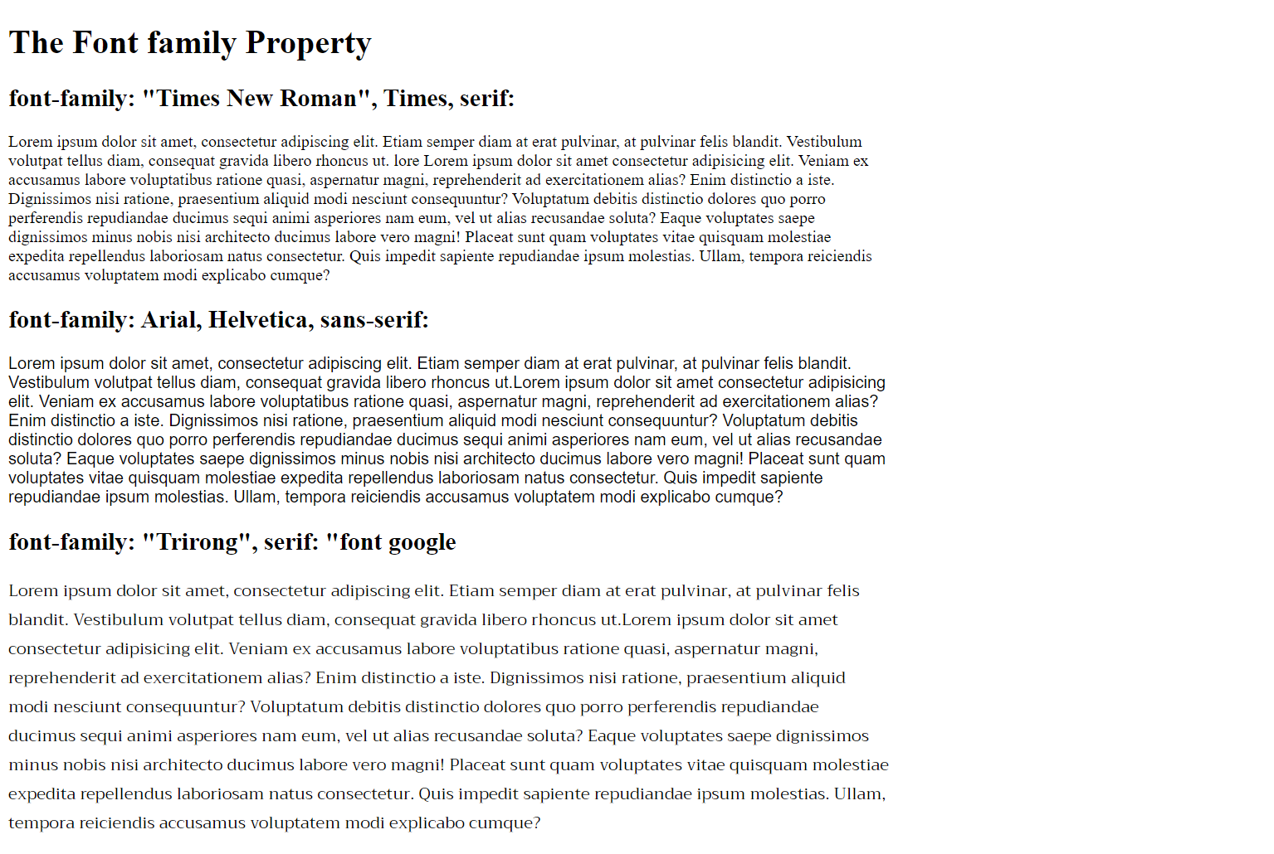

**5.Font style and font size:**

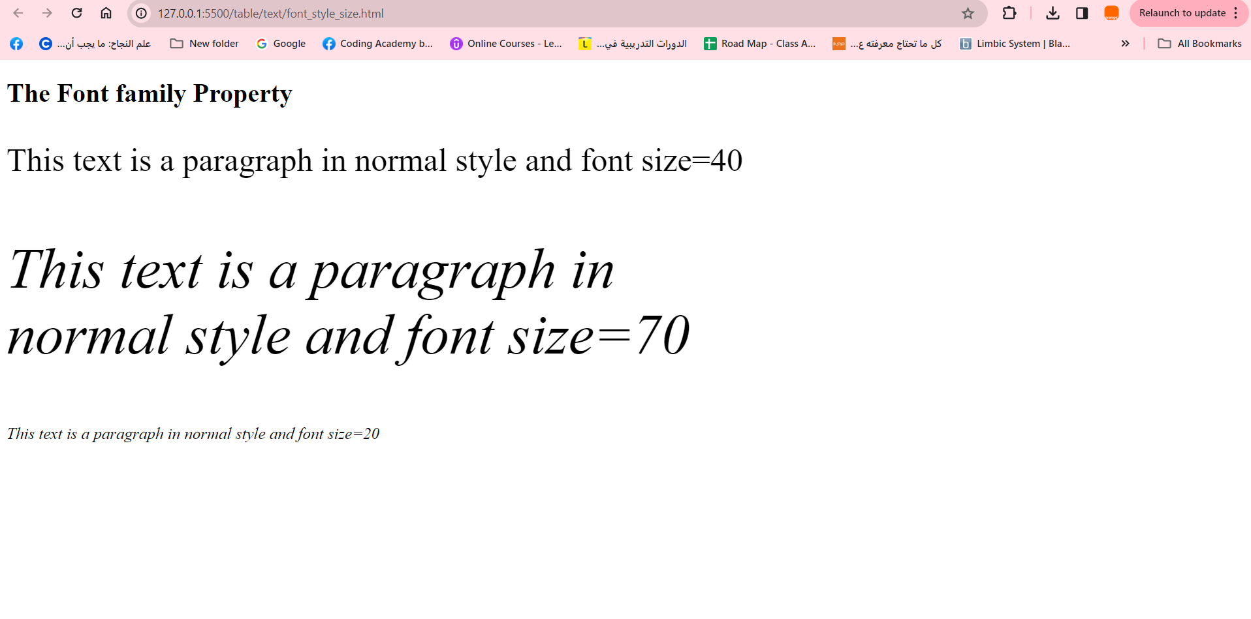

**6.Opacity:**

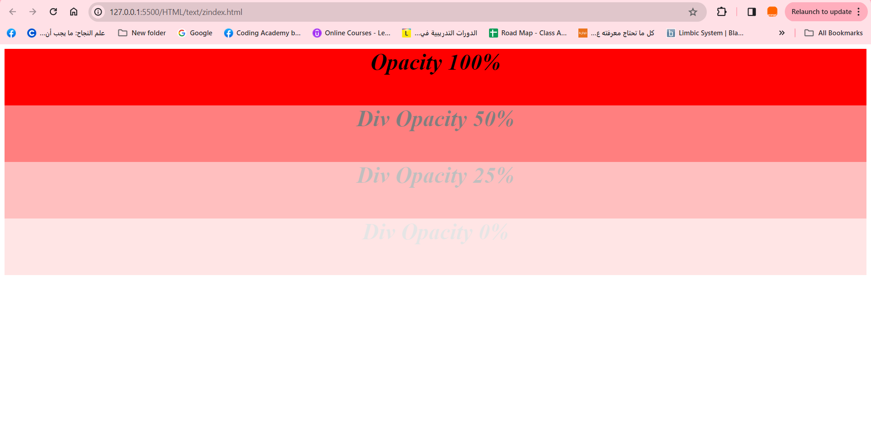

**Intermediate**

**7.Text-decoration, text-transform, text-align, font-style:**

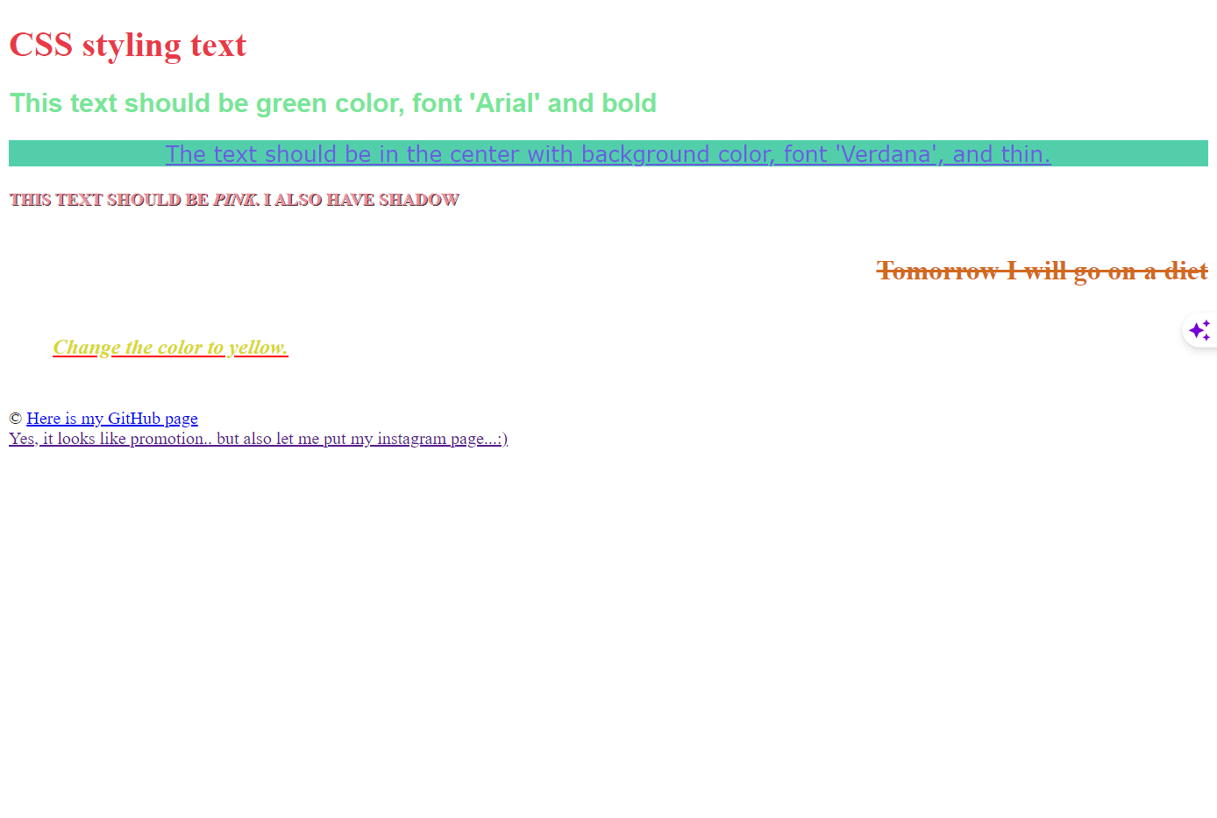

**8.Overflow:**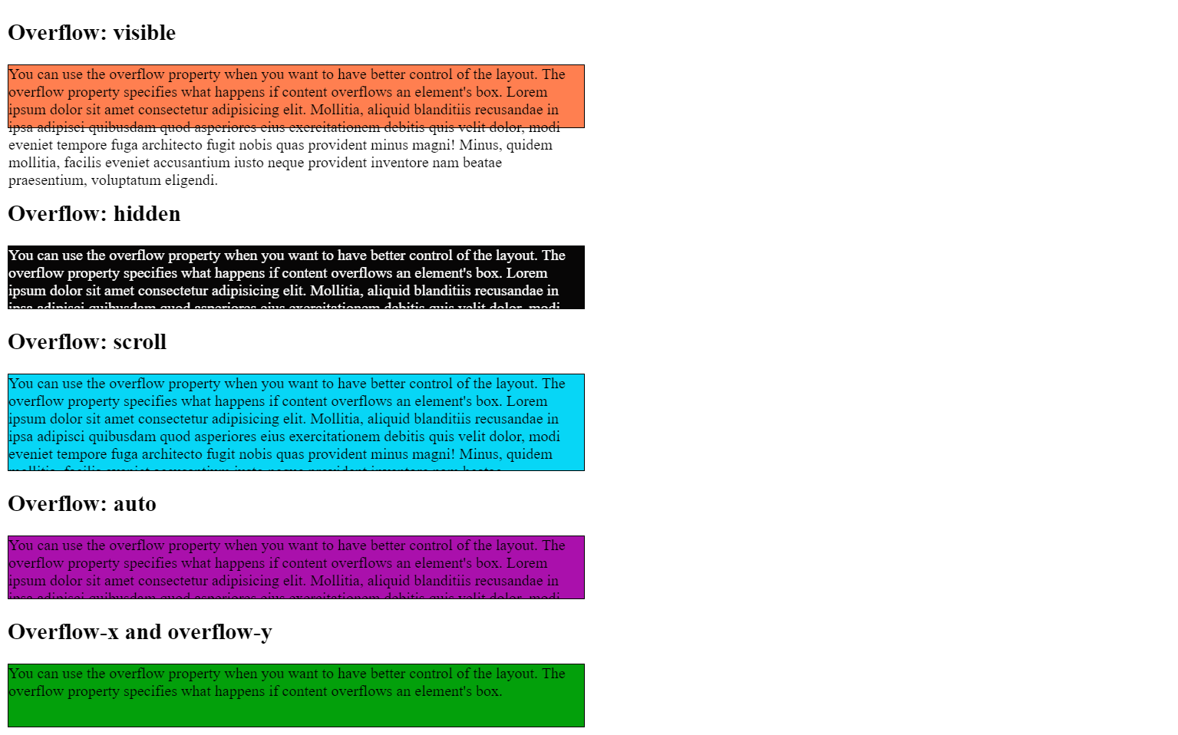

**Advanced**

**9.Create the following, based on the following:**

**1.underline decoration**

**2.a)div width=400px**

**b)add scroll for div**

**3.a)font family= 'Lucida Sans', 'Lucida Sans Regular', 'Lucida Grande', 'Lucida Sans Unicode', Geneva, Verdana, sans-serif**

**b)font-size=20px**

